Review Article
Evaluating the Generalization of Promoter Prediction Models on Independent Genomic Data
Muhammad Mohsin Farooq, Muhammad Shujaat, Dr. Zia ul Rehman

Department of Computer Science, Government College University, Lahore
Email: mmohsinfh@gmail.com

Department of --------------, ---- University, China
Email: xyz@gmail.com

Department of Computer Science, Government College University, Lahore
Email: ziaulrehman@gcu.edu.pk

Correspondence Email: xyz@gmail.com
Abstract
Promoter regions play a crucial role in gene regulation, yet their accurate identification across diverse biological domains remains a challenge. While recent advancements in deep learning and transformer-based models have shown promise in enhancing prediction accuracy, their real-world applicability and ability to generalize to unseen data remains a concern. In this study, we evaluate the performance of existing promoter prediction models from the previous decade using an independent, curated dataset that spans prokaryotic, eukaryotic, and archaeal sequences. Our findings reveal significant gaps between reported benchmark performance and the true generalization abilities of these models, particularly highlighting issues such as overfitting, model bias, and limited robustness. Despite these challenges, our analysis points to areas for improvement, revealing that while some models perform well for specific promoter classes, others, like those for certain sigma factors, struggle to generalize effectively. The results underscore the need for greater transparency, reproducibility, and robustness in promoter prediction models, as well as improved methodologies that can effectively generalize across diverse and independent datasets. This work not only exposes the limitations of current models but also provides valuable insights for future improvements in promoter prediction, ultimately aiming for more accurate and generalized predictions that can better serve genomics research. All associated resources, implementations, and datasets are made publicly available at: [GitHub].

Keywords: promoter prediction; deep learning; transformer models; genomic sequences; model generalization; bioinformatics

Introduction

The Central Dogma of Molecular Biology describes the unidirectional flow of genetic information from DNA to RNA to protein Transcription is the essential biological process by which RNA is synthesized from a DNA template, and it serves as the first step in gene expression. A promoter is a DNA sequence or set of sequences located upstream (5′) of a gene or transcription start site that serves as the binding site for the transcription machinery and thus controls the initiation of transcription. The process of transcription varies across different domains of life, including prokaryotes, eukaryotes, and archaea, although the basic principles remain conserved. In prokaryotes, transcription occurs in the cytoplasm, where RNA polymerase binds to the promoter with the sigma (σ) factor. Termination occurs via rho-dependent or rho-independent mechanisms (1). In eukaryotes, transcription occurs in the nucleus and involves three RNA polymerases: I for rRNA, II for mRNA, and III for tRNA. Transcription begins with a pre-initiation complex at the promoter, including RNA polymerase II and transcription factors. The RNA undergoes modifications like 5' capping, splicing, and 3' polyadenylation before being exported for translation (2). In archaea, transcription resembles both prokaryotes and eukaryotes. Archaea use an RNA polymerase similar to eukaryotic RNA polymerase II for transcribing all genes. Transcription begins with transcription factors binding to the promoter, recruiting RNA polymerase, unwinding DNA, and synthesizing RNA. Termination occurs via factors similar to eukaryotes. Despite shared frameworks, differences in machinery and regulation highlight the complexity of gene regulation across domains (3).
The promoter “promotes” the start of transcription by positioning RNA polymerase in the correct orientation and providing binding sites for regulatory proteins. In prokaryotes, the canonical bacterial (σ^70-type) promoter has two main short consensus elements: the “–35” element often with consensus TTGACA, and the “–10” element typically with consensus TATAAT, plus an optimal spacer (often about 16–19 base pairs, often ~17 bp) between –35 and –10. These sequences help the σ factor of RNA polymerase recognize and bind the promoter. There may also be an extended “–10” motif, UP elements upstream, or discriminator sequences, etc. (1). In eukaryotes, promoters are more complex: they often include a core promoter containing elements such as a TATA box, an initiator element overlapping the +1 site, and sometimes a downstream promoter element or BRE (TFIIB recognition element). Upstream promoter regions may contain CAAT boxes, GC boxes, and further upstream or distal regulatory elements (enhancers, silencers) that interact by looping. In plants, promoter structure is broadly similar to that in other eukaryotes, with core promoter elements plus plant-specific regulatory motifs, and also upstream enhancers or upstream activating sequences (2). In archaea, the promoter architecture is sort of intermediate between prokaryotes and eukaryotes: archaeal promoters often include a TATA box and an upstream BRE that is recognized by archaeal transcription factor B, plus sometimes an initiator or “promoter proximal element” between BRE/TATA and the start site. The archaeal transcription machinery is simpler than eukaryotic but more complex than bacterial. Within each of these organisms, there are different types or classes of promoters depending on regulation. In bacteria, you have constitutive promoters, regulated promoters, σ-factor specific promoters, strong vs weak promoters, and hybrid promoters. In eukaryotes, there are housekeeping promoters, developmental or tissue-specific promoters, enhancer-dependent promoters, inducible promoters, bidirectional promoters, and TATA-containing vs TATA-less promoter classes. In plants, you also see constitutive promoters, tissue-specific promoters, stress-inducible promoters, light-responsive promoters, etc. (2). In archaea, promoters may be strong or weak depending on how close their sequences are to consensus in the BRE/TATA/Inr regions, or may vary in the presence or absence of accessory promoter-proximal elements (3).
The importance of promoters in gene regulation is fundamental to understanding gene expression and cellular function. In the early stages of research, promoter prediction was primarily carried out through ‘wet-lab techniques’, such as reporter assays and gel shift assays, which were labor-intensive and time-consuming. These methods allowed for the identification of promoter regions, but they were limited by their ability to analyze large datasets or predict unknown promoter sequences. As ‘computational models’ entered the scene, they brought a significant shift in the process of predicting promoters. Early models, such as Hidden Markov Models and Support Vector Machines, began to automate the prediction process by identifying sequence patterns in the DNA. These computational tools, while not as sophisticated as today’s models, marked the first step toward automating promoter identification and laid the foundation for more complex techniques in the future. With the rise of ‘machine learning’, the accuracy of promoter prediction greatly improved. ML algorithms like Random Forests and Gradient Boosting Machines allowed researchers to process larger datasets, learn from them, and refine their predictions. Machine learning models could better capture complex relationships within genomic data, leading to more reliable predictions of promoter sequences, even when faced with noisy or incomplete datasets. The most significant breakthrough in recent years has been the application of deep learning and artificial intelligence. Techniques like Convolutional Neural Networks and Recurrent Neural Networks have revolutionized promoter prediction by enabling the models to automatically learn from raw DNA sequences and uncover intricate sequence patterns. These deep learning models have greatly enhanced the sensitivity and specificity of predictions, making them invaluable tools for genomics research. Each progression has contributed to a more efficient and precise approach to promoter prediction. These advancements have not only made the process faster but have also expanded the scope of genomic research, allowing scientists to predict novel promoter regions and understand gene regulation with greater accuracy (4).
Promoter can be categories as weak or strong promoter. But what factors determine whether a promoter is “strong” or “weak”? there are five keyfactors influence promoter strength. First, the degree of match to the consensus sequences, the closer to consensus, the better the binding by sigma factor or transcription factors, and thus often higher transcription. Second, the spacing between elements. Third, flanking sequences, discriminator regions, UP elements or upstream proximal elements and enhancers can enhance or diminish transcription. Fourth, availability and concentration of transcription factors or sigma factors, chromatin context affect promoter accessibility. Fifth, DNA topology, supercoiling, DNA methylation, local DNA secondary structures and transcription factor binding affinities play roles. Also, regulatory proteins binding near promoter modulates the effective strength by recruiting or blocking the basal machinery. Thus a “strong promoter” is one that recruits the transcription machinery effectively and yields relatively high initiation frequency, while a “weak promoter” has poorer binding or is more repressed [1] [2].
In this study, we performed a comprehensive analysis of the existing work on promoter prediction, focusing on the number of studies for each species, including prokaryotic, eukaryotic, and archaeal organisms. This work highlights the limitations of the models, particularly in terms of the availability of pre-trained model weights. We have also discussed how these models perform when applied to independent datasets, shedding light on their effectiveness and the areas where improvements are needed.

Overview of Reviewed Studies

In examining the landscape of promoter prediction research, we conducted an extensive review of 63 (view) recent research articles that collectively address the computational identification of promoter sequences across different domains of life. Among these studies, the vast majority around 38 publications focus on prokaryotic promoter prediction, primarily targeting bacterial species such as Escherichia coli and Bacillus subtilis. About 15 papers concentrate on eukaryotic systems, with particular emphasis on human, mouse, Arabidopsis thaliana, and other plant species. Around 7 research articles with the core focus on the both prokaryotic and eukaryotic species. A smaller but growing body of work, comprising roughly 3 papers, specifically addresses archaeal promoter prediction as shown in the figure, targeting organisms like Sulfolobus solfataricus, Haloferax volcanii, and Thermococcus kodakarensis. Additionally, one paper stands out as it reports laboratory experimental work on phytoremediation using aquatic plants, though it diverges from the core computational focus of the other studies.
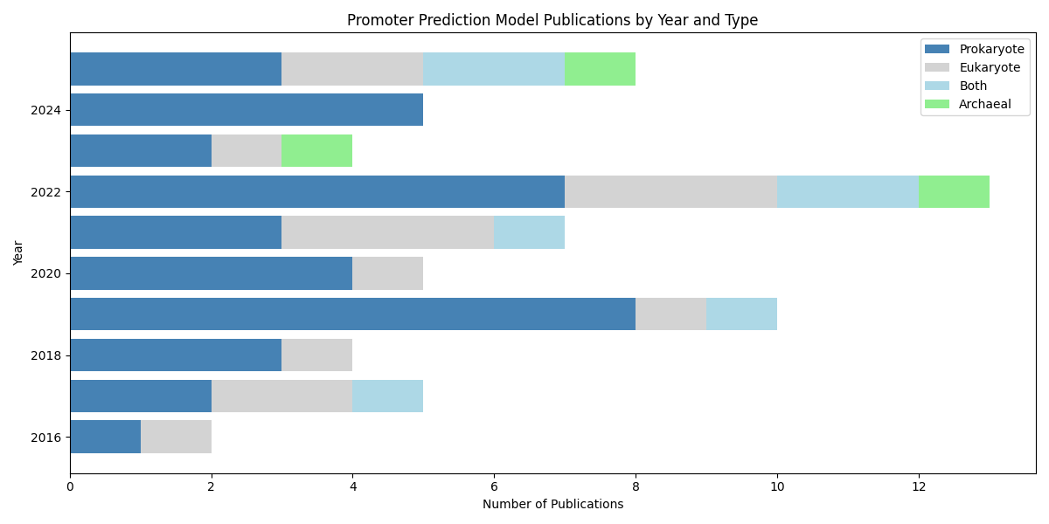
Figure: Trends in Promoter Prediction Model Publications by Year and Type. The chart illustrates the number of publications across four categories: Prokaryote, Eukaryote, Both, and Archaeal, from 2016 to 2025.
When examining the datasets employed across these domains, clear patterns emerge in terms of preferred data sources and their characteristics. For prokaryotic studies, RegulonDB emerges as the dominant resource, providing experimentally verified promoter sequences for E. coli across multiple sigma factor types. Many prokaryotic papers utilize a standard benchmark consisting of 741 experimentally confirmed sigma-70 promoters paired with 1,400 non-promoter sequences, each spanning 81 base pairs from position negative 60 to positive 20 relative to the transcription start site. Some studies expanded beyond E. coli to include data from other bacterial species, with Pro54DB serving as a specialized repository for sigma-54 promoters across dozens of bacterial species, containing around 210 curated sequences in its 2017 release. For eukaryotic promoter prediction, researchers primarily draw upon the Eukaryotic Promoter Database and the Database of Transcriptional Start Sites, which collectively house tens of thousands of human promoter sequences along with data from mouse and other model organisms. Plant-specific studies rely heavily on PlantProm, PlantPAN, and the Plant Promoter Database, which aggregate hundreds to thousands of experimentally validated plant promoter sequences from species like Arabidopsis, rice, maize, and soybean. The archaeal studies, being more recent and specialized, compiled their own datasets from experimental literature like gathering experimentally confirmed promoter sequences from archaeal species.

Evolution of Embedding and Feature Extraction Techniques for DNA Sequences

Feature encoding schemes refer to the methods used to represent raw data in a structured format that can be understood by machine learning models. In the context of genomics and DNA sequence analysis, these encoding techniques are crucial because they convert complex biological sequences into numerical representations that allow models to process and learn from the data. Without such encoding, machine learning algorithms would not be able to interpret the vast, unstructured data provided by DNA sequences.

The evolution of embedding and feature extraction techniques across these papers reveals a fascinating progression from simple to increasingly sophisticated representations. In earlier work spanning roughly from 2016 to 2019, studies predominantly employed classical encoding schemes such as one-hot vectors where each nucleotide is represented as a binary vector, k-mer frequency counts that capture the frequency distribution of short nucleotide patterns, and position-weight matrices derived from known motif databases. These techniques were foundational in translating genetic data into formats that machine and deep learning algorithms could use to identify patterns and make predictions. Mathematically, k-mer based representation can be expressed as a feature vector:

X = [f₁, f₂, f₃, ..., fₙ]

Here each fᵢ denotes the normalized frequency of a specific k-mer within the DNA sequence. Many studies introduced pseudo-nucleotide composition methods, with variations like PseKNC capturing k-tuple patterns augmented with physicochemical properties, and PseZNC merging Z-curve descriptors with DNA structural features to incorporate long-range dependencies. Other specialized encodings included position-specific trinucleotide propensity, electron-ion interaction pseudopotentials, and dinucleotide-based auto-covariance features, all designed to reflect biological properties such as DNA stability, curvature, and hydrogen bonding characteristics. As the field matured, particularly from 2019 onward, researchers began treating DNA sequences more like natural language and adopted word embedding approaches. DNA2Vec emerged as a popular technique, analogous to Word2Vec in natural language processing, where overlapping k-mers are embedded into dense continuous vector spaces that capture contextual relationships between subsequences. Some studies generated continuous n-grams using FastText embeddings with sub-word fragments of varying lengths from one to ten nucleotides, producing high-dimensional feature vectors that preserve subtle sequence patterns. The most recent papers, particularly those from 2022 to 2025, have embraced transformer based pre-trained models such as BERT and its DNA-specific variants like DNABERT and Longformer adaptations. These models use bidirectional attention mechanisms to learn rich contextual representations from large corpora of genomic sequences, with some approaches even integrating external biological knowledge from resources like Gene Ontology to create knowledge-enhanced embeddings that combine sequence information with functional annotations. The underlying self-attention mechanism can be mathematically expressed as:

Attention(Q, K, V) = softmax((QKᵀ) / √dₖ) V

where Q (query), K (key), and V (value) are matrices derived from the input embeddings, and dₖ represents the dimensionality of the key vectors. This formulation allows the model to assign varying importance to different nucleotide positions, enabling the capture of long-range dependencies within DNA sequences. In general, deep learning models used for promoter prediction can be represented mathematically as:

Y=f(Wx+b)

Here, x represents the input feature vector derived from DNA sequences, W denotes the learned weight matrix, b is the bias term, and f is a non-linear activation function such as ReLU or sigmoid. The output y represents the predicted probability of a sequence being a promoter. To optimize the model during training, a loss function such as binary cross-entropy is commonly used:

Loss = - [y log(ŷ) + (1 - y) log(1 - ŷ)]

where y is the true label and ŷ is the predicted probability.
Beyond encoding strategies, several other methodological elements appear consistently across these studies and have become standard practices in the field.

Techniques for Addressing Dataset Imbalance and Advancing Promoter Prediction Models

These papers universally address the challenge of dataset imbalance by constructing balanced training sets, typically pairing each promoter sequence with an equal number of carefully selected non-promoter sequences drawn from coding regions, intergenic spaces, or shuffled fragments. To prevent overfitting and ensure robust generalization, tools like CD-HIT are routinely employed to remove redundant sequences sharing more than 90 percent similarity. Cross-validation techniques, particularly five-fold and ten-fold schemes, serve as the primary evaluation framework, often supplemented by independent test sets drawn from newer database releases or different species to assess model transferability. Feature selection has become increasingly important as feature spaces expanded into thousands of dimensions, with methods ranging from recursive feature elimination and F-score ranking to tree-based importance measures from random forests and XGBoost, and more recently, attention mechanisms and SHAP values that provide interpretable insights into which sequence positions most strongly influence predictions. On the modeling side, support vector machines with radial basis function kernels dominated early machine learning efforts, frequently achieving 80 to 95 percent accuracy when paired with well-engineered features. Ensemble methods like random forests, AdaBoost, and gradient boosting gained traction for their robustness and ability to handle complex interactions between features. The deep learning revolution brought convolutional neural networks to the forefront, with typical architectures employing one-dimensional convolutions to scan for motif patterns, max pooling to capture position-invariant features, and fully connected layers for final classification. Many recent papers favor hybrid architectures that combine convolutional layers for local motif detection with bidirectional LSTM or RNN layers to capture long-range dependencies and attention mechanisms to highlight informative sequence regions. Multi-layer or multi-task frameworks have also proliferated, particularly for problems requiring both promoter detection and subsequent classification into subtypes such as sigma factor classes or strength categories, with one layer identifying promoters and a second layer performing fine-grained classification on the detected promoters.

Advancements and Challenges in Promoter Prediction

Reflecting on these studies, it becomes evident that promoter prediction has evolved from a challenging bioinformatics problem tackled with simple motif scanning and statistical models into a sophisticated domain where cutting-edge machine learning and deep learning techniques are routinely applied. The progression spans from early efforts using handcrafted features and traditional classifiers achieving modest accuracy, through the adoption of convolutional neural networks that automated feature learning and substantially improved performance, to the current frontier where transformer-based models incorporating biological knowledge and interpretable AI frameworks push accuracies beyond 95 percent on well-defined benchmarks. Despite this impressive progress, challenges remain, particularly in generalizing models across species, handling class imbalance for rare promoter types, reducing false positives in genome-wide scans, and making predictions interpretable for biologists. Nevertheless, the field has clearly demonstrated that computational approaches can effectively complement experimental methods, offering rapid, cost-effective screening of genomic sequences for candidate promoters while continuously refining predictions as new data and techniques emerge.
The availability of web servers and user-friendly tools accompanying many of these studies further democratizes access to state-of-the-art promoter prediction, enabling researchers worldwide to annotate genomes, design synthetic regulatory elements, and deepen our understanding of transcriptional regulation across the tree of life.

Curated Datasets for Model Testing

The dataset utilized in this study comprises promoter sequences from a wide range of species, representing three major biological domains: Prokaryotic, Eukaryotic, and Archaea. The Prokaryotic domain includes Escherichia coli (E. coli) and Bacillus subtilis (B. subtilis), while the Eukaryotic domain features species such as Human, Plant, and Mouse. Additionally, various species from the Archaea domain were included to further enrich the dataset. These species were selected to provide a broad genetic diversity, which is crucial for evaluating the performance of promoter prediction models across different biological kingdoms. The promoter sequences for these species were curated from a combination of multiple research papers and public databases, ensuring a comprehensive set of high-quality and diverse sequences for thorough analysis.

Dataset Creation

In this study, the independent datasets were compiled from various publicly available research papers and genomic databases. The dataset creation process involved several key steps as shown in the figure. First, the data collection phase entailed gathering DNA sequences from peer-reviewed research papers and accessible genomic databases, such as RegulaonDB, EPD, and PlantPromDB. Sequences were carefully selected based on their relevance to the study’s objectives, specifically for identifying promoter regions and other genomic features of interest.

Dataset Size

We have curated an independent dataset of promoter sequences against three different classes: Prokaryotic, Eukaryotic, and Archaeal species. The following tables summarize the total number of sequences for each species class.

For Prokaryotic Species:

Prokaryotic Species | Total Sequences | Sequence Length
Escherichia coli | 9,026 | 81
Bacillus subtilis | 368 | 81
Table.1: Prokaryotic Species Promoter Sequence Distribution

For Eukaryotic Species:

Eukaryotic Species | Total Sequences | Sequence Length
Human | 48,342 | 300
Plants | 14,570 | 251
Mouse | 41,753 | 300
Table.2: Eukaryotic Species Promoter Sequence Distribution

For Archaeal Species:

Archaeal Species | Total Sequences | Sequence Length
Archaeal Promoter | 3,955 | 100
Table.3: Archaeal Species Promoter Sequence

Data Processing

Next, the data preprocessing stage involved curating the raw DNA sequences, which were provided in FASTA format. The sequences were thoroughly checked for consistency and quality, with redundant or incomplete sequences removed to maintain data integrity.
To ensure the uniqueness of the dataset, the CD-HIT algorithm was applied for unique sequence identification. With a clustering threshold set at 90%, CD-HIT helped identify and cluster similar sequences, retaining only one representative sequence from each cluster to avoid redundancy.
Finally, the resulting dataset was meticulously reviewed to guarantee it consisted of high-quality, distinct sequences. This non-redundant set of sequences represents a diverse range of genomic regions, making it well-suited for subsequent computational analyses and the training of promoter prediction models.
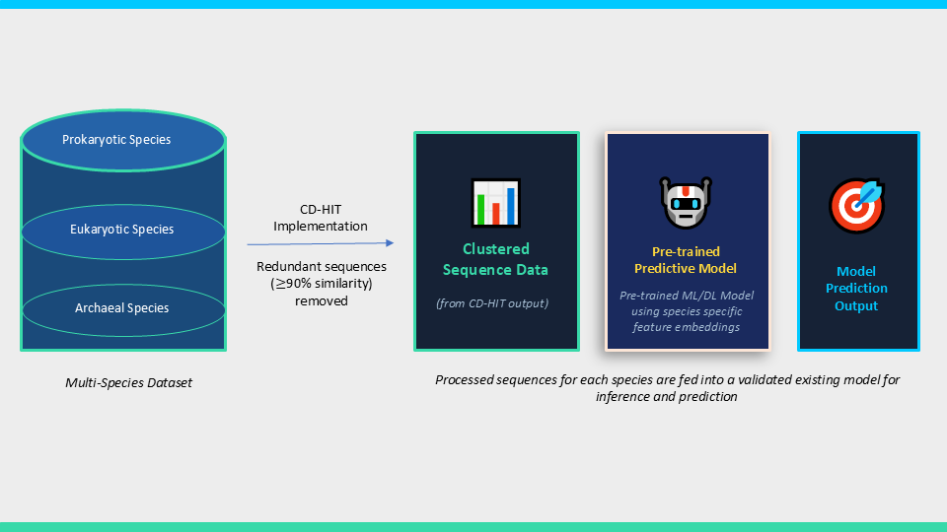
Figure: Overview of the promoter prediction pipeline. Multi-species sequences are processed using CD-HIT to remove redundant sequences (>90% similarity). The clustered sequences are then provided as input to pre-trained models for prediction.

Testing Existing Promoter Prediction Models on Independent Dataset
The curated dataset was not split into training, testing, and validation sets. Instead, it was used solely to test the performance of existing promoter prediction models. To assess how these models react to unseen data, we utilized the pre-trained weights provided by the authors of the respective models, which were obtained from their official GitHub repositories. These pre-trained models were loaded, and the independent dataset was then fed into them to evaluate their predictions on novel sequences. This approach allowed me to assess the generalizability and effectiveness of the models in predicting promoters within an independent dataset that had not been part of the original training or validation process.

In this study, several models were tested on an independent dataset using their pre-trained weights, which highlights a significant challenge in the field. Despite the review of 63 (figure) research papers, only a small fraction of the models made their pre-trained weights publicly available on platforms like GitHub. These pre-trained weights are crucial for testing models on independent datasets, but they often require fine-tuning to improve generalization when applied to unseen data. The models tested in this study span both prokaryotic and eukaryotic species, with notable examples including pcPromoter CNN, Promote Predictor, and PredPromoter-MF for prokaryotic species, DeeProPre and OntoGene for eukaryotic species, and ipro-Wael for both prokaryotic and eukaryotic species. Additionally, iPromArchaea was tested for archaeal promoters. However, the limited availability of pre-trained weights, especially for models not shared on GitHub, presents a barrier for researchers and practitioners trying to apply these models to independent datasets. This underscores the critical role of pre-trained weights in model testing and the challenges posed by their limited accessibility, despite extensive research in the field.

Taxonomy Diagram:
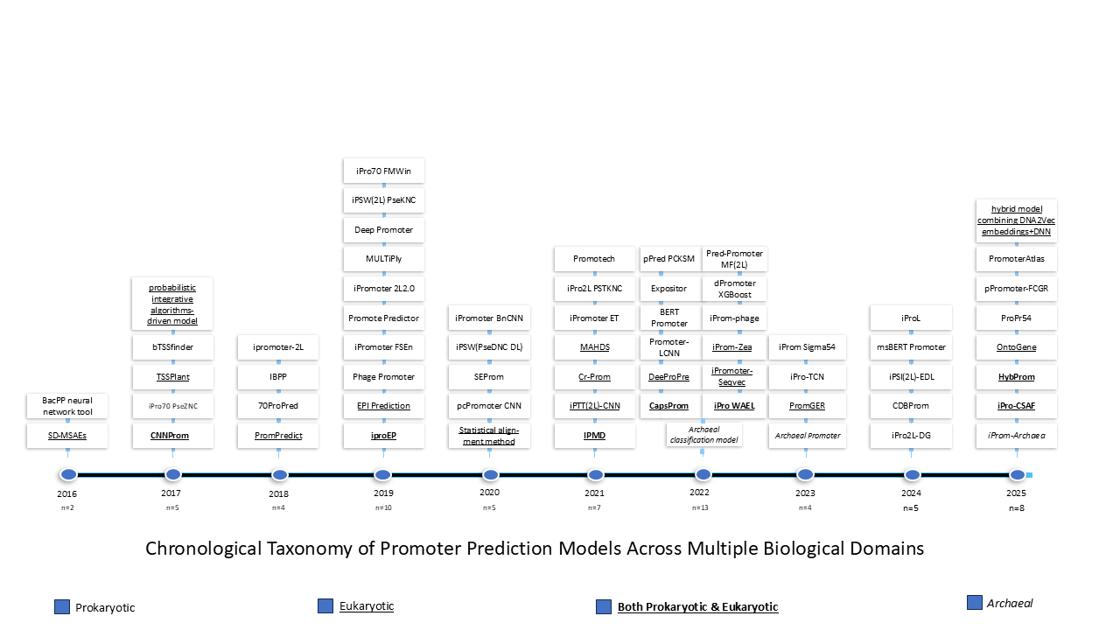
Figure.1: Chronological Taxonomy of Promoter Prediction Models Across Multiple Biological Domains (Prokaryotic, Eukaryotic, both Prokaryotic & Eukaryotic and Archaeal)
Figure presents a taxonomy of promoter prediction models developed over the past decade, arranged chronologically from 2016 to 2025. The models included in this taxonomy are collected from previously published studies and represent the approaches that have been considered and evaluated in our research. Each model is categorized based on the biological domain of the promoter sequences used in the original study. The models written in plain text represent methods specifically developed for prokaryotic promoter prediction. The underlined models correspond to approaches designed for identifying eukaryotic promoters. Models that are both highlighted and underlined indicate studies that addressed promoter prediction for both prokaryotic and eukaryotic species. In addition, the models written in italic style represent methods developed for archaeal promoter prediction. This taxonomy provides a clear overview of how promoter prediction research has evolved over the past decade across different biological domains. It also highlights the wide range of computational techniques proposed by researchers to improve promoter identification. By organizing the models according to their publication year and biological focus, the figure illustrates the gradual expansion of promoter prediction studies toward multiple species and promoter types. Most of the models included in this taxonomy have publicly available pre-trained implementations, which allowed them to be selected for comparative evaluation in our study.

Performance Evaluation of Prokaryotic Promoter Prediction Models

For prokaryotic promoter prediction, we reviewed a total of 38 research papers (5-42). Among these, only a select few provided pre-trained model weights, enabling us to test their performance on independent datasets. This approach allows us to assess how well the models respond to new data that was not included during the initial training phase.
One of the most recent advancements in promoter prediction is the “PromoterAtlas” model, which utilizes a DNA Transformer architecture designed to decode regulatory sequences across Gammaproteobacteria. The model is built with 1.8 million parameters, combining convolution filters, rotary attention, and residual connections for improved sequence analysis. It was trained on over 9 million sequences from more than 3,000 species, and the results of the model were validated using CHIP-seq and genome annotation data. As shown in Figure, the model’s capabilities include predicting 12 different types of promoter elements, such as the -35 box, -10 box, +1 site, and several spacer regions, with a validation accuracy of 95%.
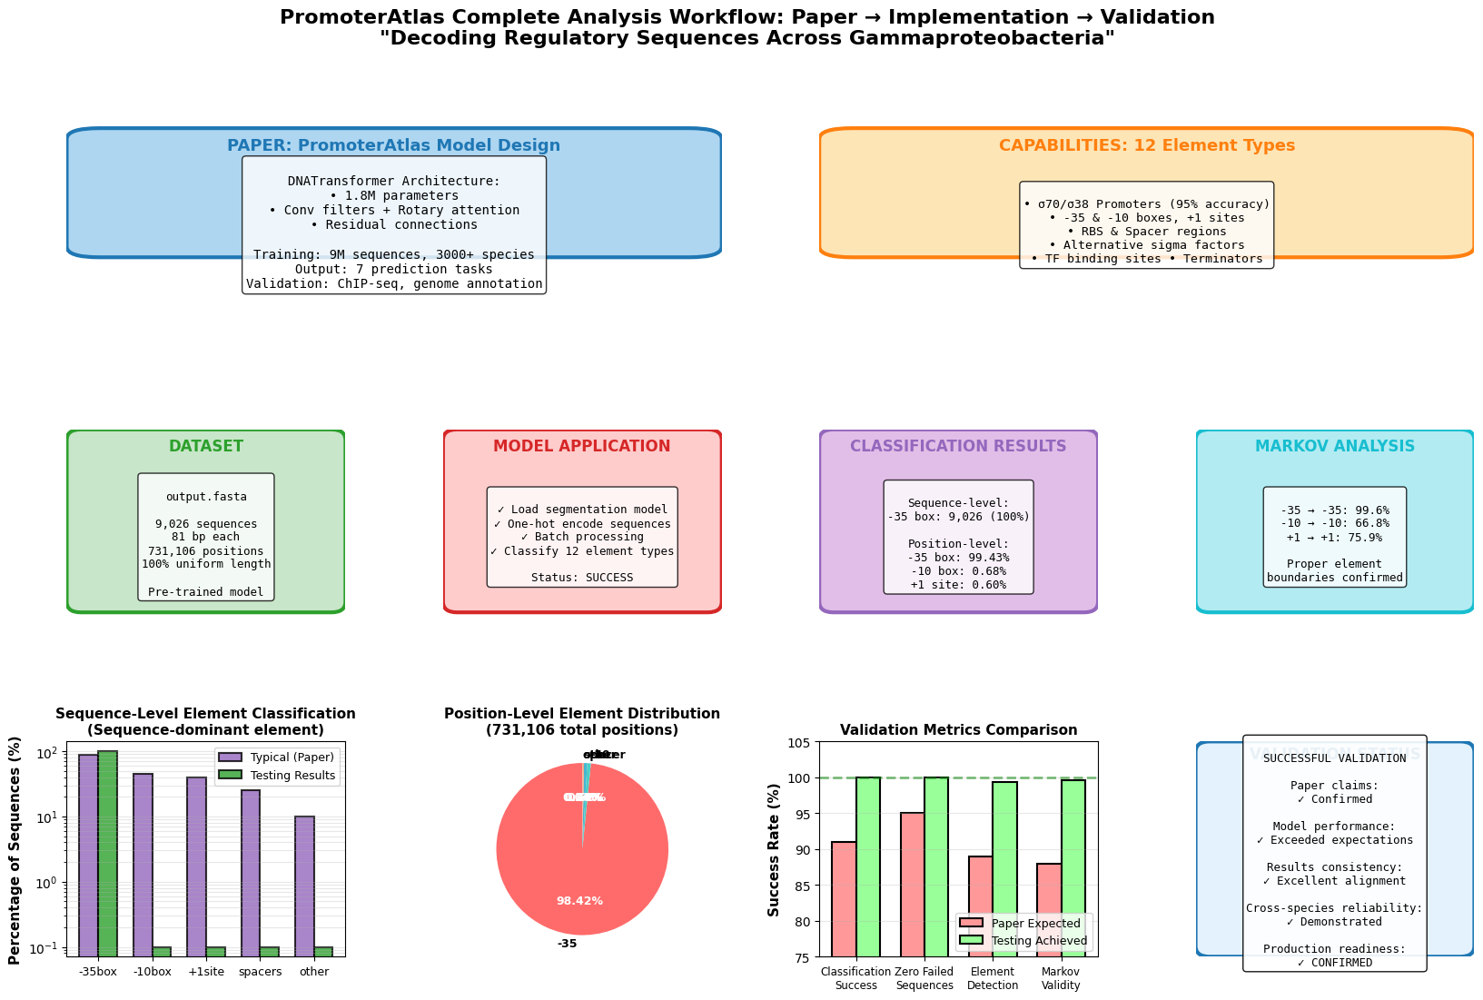
Figure.4: Promoter Atlas workflow
The dataset used for training, consists of 9,062 sequences, each with 81 base pairs, making up 731,106 total positions, and the model was trained on this uniform-length data. It was applied successfully to predict these 12 element types, with a high success rate for the -35 box (99.43%). However, elements like the +1 site showed lower accuracy. The Position-Level Element Distribution reveals that the -35 box represents the majority of the identified elements (98.42%), while other elements, such as spacers and the +1 site, make up a significantly smaller portion.
Further analysis of the model’s transition probabilities is provided in Figure, which presents an Element Transition Matrix using a Markov chain model. The transition behavior between promoter elements can be formally described using a first-order Markov chain model, where the probability of transitioning from one element to another depends only on the current state:

P(Xn+1+j Xn=i = Tij

Here, P(Xₙ₊₁ = j | Xₙ = i) represents the probability of transitioning from element i to element j, and Tᵢⱼ denotes the transition probability in the matrix. This formulation allows the model to capture sequential dependencies between promoter elements such as the −35 box, −10 box, spacers, and transcription start site.
This matrix shows the likelihood of one promoter element transitioning into another, with -35 box having a high transition probability (0.67) to the -10 box, and spacers showing similar transition probabilities. The matrix highlights how these elements are typically organized within the sequences. The downstream and transcription start regions show strong transitions, with a probability of 0.80, indicating that the model effectively identifies sequential patterns across promoter regions.

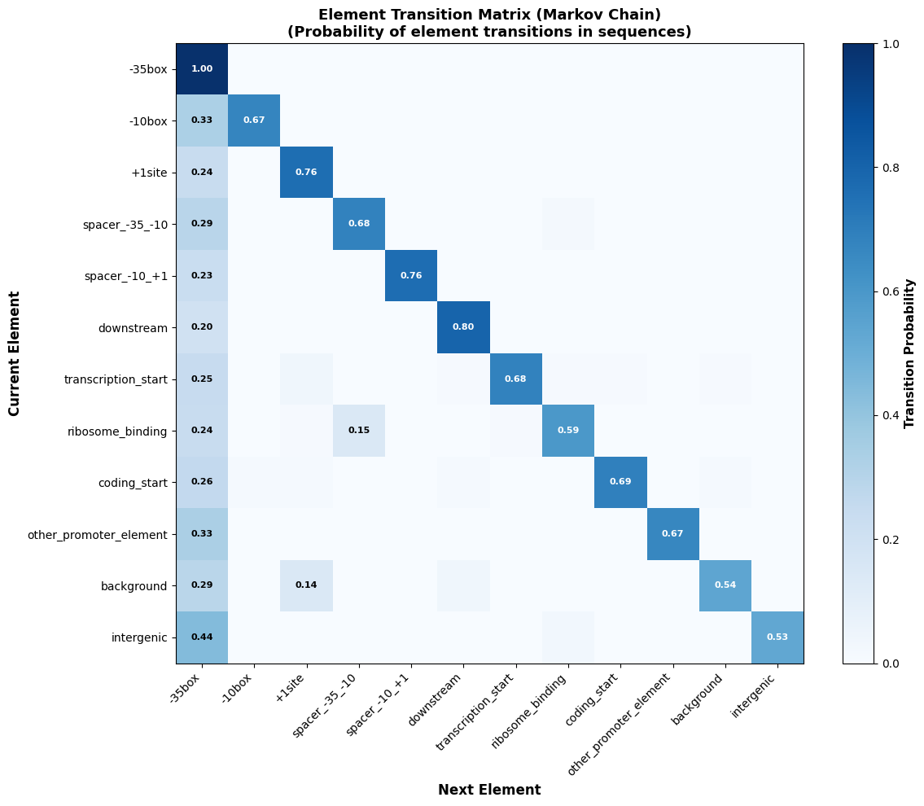

Figure.5: Element transition matrix
Despite these successes, there are some limitations in the model’s performance. The Position-Level Classification Results show that the model struggles to detect the +1 site, with much lower transition probabilities. This indicates that some promoter elements, particularly those less frequent or variable in their sequences, may not be detected as accurately. Moreover, while the -35 box elements are identified with high precision, the overall detection of less-dominant elements could be further improved. While the “PromoterAtlas” model demonstrates strong performance in predicting major promoter elements like the -35 box, it faces challenges with less-conserved elements, and there is room for further optimization, especially in generalizing to new, unobserved promoter sequences. The transition matrix analysis also provides insights into the typical structural relationships between promoter elements, aiding in further model refinement and validation.
To evaluate the performance of promoter prediction models on the independent dataset, standard classification metrics were used. These metrics quantify the model's ability to correctly identify promoter and non-promoter sequences.

Accuracy = TP+TNTP+TN+FP+FN

Precision = TPTP+FP

Sensitivity = TPTP+FN

F1-score = 2 × Precision x RecallPrecision + Recall

where TP and TN represent the number of true-positive samples and true-negative samples, respectively; and FP and FN represent the number of false-positive samples and false negative samples.

The evaluation of the “pcPromoter” model on an independent, unseen dataset reveals a mixed and somewhat inconsistent performance, highlighting both its strengths and significant limitations. The model achieved an overall accuracy of 0.73, with a weighted precision of 0.79, recall of 0.73, and F1-score of 0.75 as shown in figure, indicating a reasonable general ability to classify sequences. However, a deeper class-wise analysis exposes critical weaknesses. Notably, the model completely failed to identify the promoter class, yielding zero precision, recall, and F1-score, which strongly suggests that the model is biased or unable to generalize beyond the distribution of its training data. Among sigma factor classes, performance varies considerably: SIGMA24 and SIGMA70 show relatively strong recall values (0.83 and 0.82, respectively), indicating that the model can detect these classes to some extent, although precision remains moderate. In contrast, classes such as SIGMA32 and SIGMA38 exhibit very poor performance, with extremely low recall and F1-scores, demonstrating the model’s inability to correctly capture their underlying patterns. The absence of predictions for SIGMA54 (support = 0) further limits the evaluation for that class.
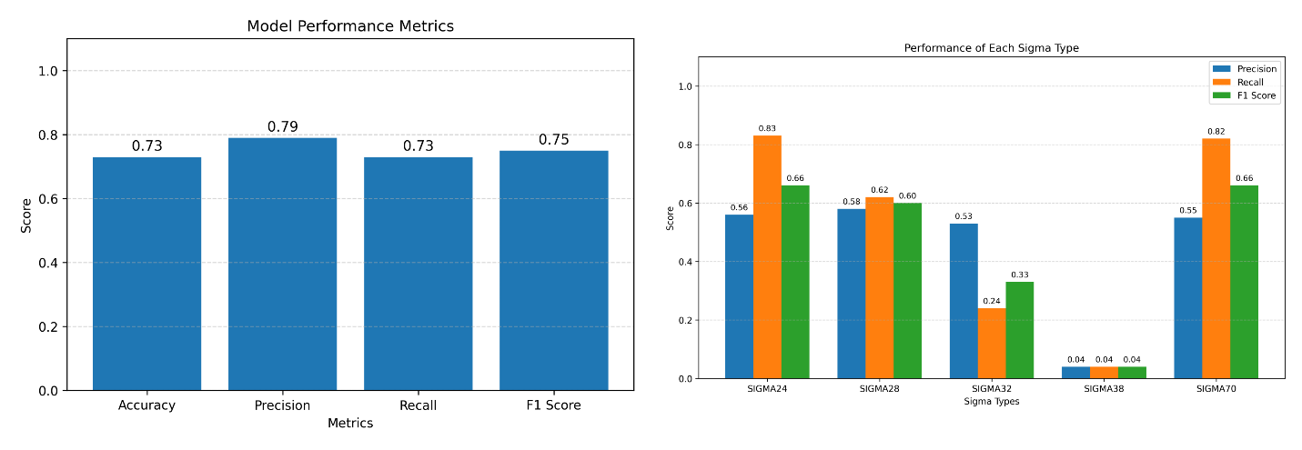
Figure.7: pcPromoter Model performance over the unseen Data
These results highlight a key limitation of the “pcPromoter” model: poor generalization to independent datasets. The discrepancy between overall accuracy and per-class performance suggests that the model is likely overfitted to the original training data and fails to adapt to variations in unseen sequences. The imbalance in class predictions and the complete failure on certain classes indicate that the learned feature representations are not robust or sufficiently discriminative across all promoter types. Furthermore, the model appears to favor dominant or more easily distinguishable classes, while neglecting minority or complex classes. This raises concerns about its reliability in real-world applications, where diverse and previously unseen data are common. Overall, while the model demonstrates moderate aggregate performance, its inconsistent behavior across classes and inability to generalize effectively limit its practical applicability and highlight the need for improved feature representation, balanced training strategies, and more robust validation on diverse datasets.
Building on the discussion of the model presented earlier in the paper, the evaluation of the “CBDProm” model on an independent dataset has yielded noteworthy insights. Originally reported to achieve 87% accuracy on a curated dataset, the model showed a significant performance decline when tested on the independent dataset (Figure). While the results were promising on a smaller, controlled dataset with an efficient accuracy, its performance on the independent, larger dataset dropped to only 46.5%. This dramatic contrast suggests that the model may have been overfitted to the smaller dataset, or the pre-trained weights may not generalize effectively to unseen data. Notably, the model's precision was perfect at 1.0, which likely indicates an imbalance in the dataset or a bias towards predicting one class (i.e., promoters). Despite this, the recall for the promoter class was only 47%, further highlighting the model's challenge in correctly identifying all true promoters in the independent dataset. These results underscore that, although model performed well on the initial dataset, it struggles to generalize to diverse, independent datasets, emphasizing the importance of thorough evaluation on varied data for ensuring real-world applicability.
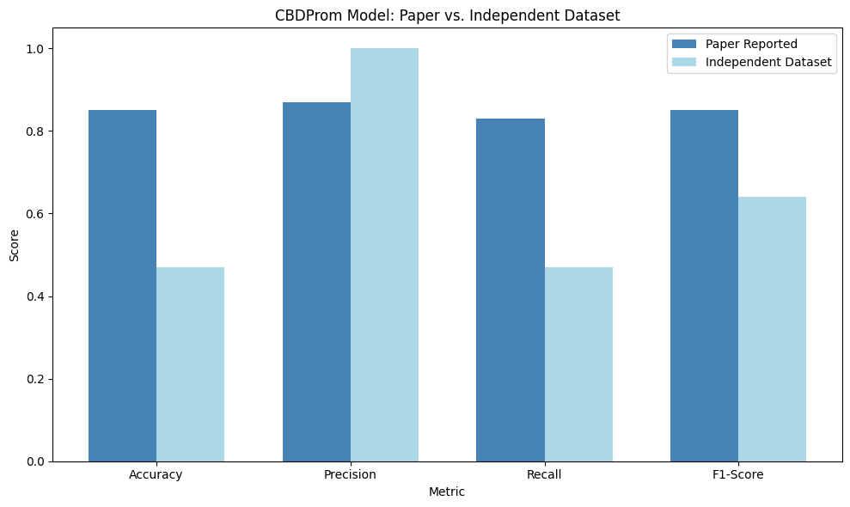
Figure.6: CBDProm Model results over the Independent Dataset
In evaluating the iProm-sigma54 model, the results across various performance metrics indicate strong performance. The model achieved an accuracy of 93.48%, demonstrating its ability to correctly classify a majority of the instances. Furthermore, the model's precision is perfect at 1.0, which indicates that it makes very few false positive predictions, likely reflecting an excellent fit for predicting promoters. The recall, or sensitivity, is also impressive at 93.48%, meaning that the model effectively identifies the majority of true positive promoter sequences. Finally, the F1-score, which balances precision and recall, is 96.63%, further underscoring the model’s strong ability to predict promoters with both high precision and recall. These results suggest that the iProm-sigma54 is highly reliable for specific type of promoter (sigma-54) prediction tasks, effectively balancing both the detection of true positives and minimizing false positives.
Building upon the evaluation of the previously discussed models, the “PredPromoter-MF (2L)” model was analyzed using its pre-trained Deep Forest framework for promoter prediction and sigma factor specificity. It utilizes multiple trained classifiers, including a general promoter predictor and sigma factor–specific models, to perform batch predictions. The outputs include probability scores and structured prediction results, which are further organized into reports for downstream analysis (view). However, the evaluation could not be completed in current setup due to a software compatibility issue between the original Keras 2.x-based implementation and the modern Keras 3.x environment. This should be considered an evaluation-environment limitation rather than a definitive limitation of the model itself. Future work may address this by reconstructing the original dependency stack or adapting the implementation to current deep-learning libraries.
Building upon the evaluation of the aforementioned models, the “Promote-Predictor” model was considered for testing on an independent dataset. However, the model relies on a fixed set of 727 handcrafted features that cannot be generated from raw FASTA sequences without reproducing the exact feature extraction pipeline used by the authors. In the provided implementation, the file (extractor.jar) is tightly coupled to the original dataset through hard-coded headers, and the feature extraction methodology is not sufficiently documented. Additionally, the Java implementation lacks modularity and does not support direct processing of raw FASTA sequences. Consequently, without reconstructing the complete feature extraction pipeline, any attempt to generate predictions would be scientifically unreliable. This represents a critical reproducibility limitation, significantly restricting the model’s applicability for independent validation and comparative analysis.

Performance Evaluation of Eukaryotic Promoter Prediction Models

For eukaryotic promoter prediction, we analyzed a total of 15 papers (43-57), out of which only two papers, Deepropre and Ontogene, provided pre-trained model weights. However, significant limitations were encountered when attempting to test these models on our curated independent dataset.
For “Deepropre”, the primary issue was an incompatibility between the provided pre-trained weight file and the given model architecture. TensorFlow reported a mismatch in the number of layers, indicating that the model used to save the weights differed from the expected architecture. Additionally, the weight file was not in a compatible format, resulting in a "bad magic number" error when attempting to load the weights. This issue prevented the use of the pre-trained weights on our independent dataset, as the weights were incompatible with the current model structure. As a result, predictions on datasets like Human or Mouse FASTA files could not be made unless the original training model was available, or the model was retrained from scratch to generate compatible weights.
In the case of “Ontogene”, the model consistently classified all sequences as promoters when tested on the independent dataset (view). This issue suggested that the pre-trained weights had problems with key parts of the model architecture, including the classifier and pooling layers. These mismatched or missing weights led to inaccurate predictions. The underlying issue was likely an imbalance in the training data, where the "promoter" class was overrepresented, causing the model to develop a bias towards predicting promoters. Furthermore, the model might have suffered from improper calibration during training, leading to skewed predictions. While the model could still be used for testing without fine-tuning, the accuracy would be compromised due to these issues. Fine-tuning the model on a more balanced dataset would be necessary to address the class imbalance and improve the model's ability to correctly distinguish between promoters and non-promoters. These limitations highlight the challenges of using pre-trained models without proper access to the original training setup or the ability to fine-tune the model.

Performance Evaluation of both Prokaryotic and Eukaryotic Promoter Prediction Models
For both eukaryotic and prokaryotic species, out of 7 papers (58-64) only iPro-Wael has access to their trained model weights, which was originally designed and trained for protein sequence prediction, on promoter sequences to assess its ability to generalize to a different biological context. We tested the model using an independent dataset of promoter sequences from B. subtilis and E. coli. The results of the evaluation, which included both CNN and Random Forest (RF) models, showed similar performance for both species. The CNN model predicted 225 positive and 511 negative sequences for B. subtilis, and 6389 positive and 11663 negative sequences for E. coli, with mean probabilities of 0.4874 and 0.4907, respectively, and a standard deviation of 0.0290 for both as shown in the figure. The RF model showed identical results for both organisms. Despite the model’s reasonable performance, it is important to note that the iPro-Wael model was not trained specifically for promoter sequences, which could explain its relatively modest performance on this task. While the results did not show a drastic decline compared to its original use case on protein sequences, the application to promoter sequences indicates that the model’s accuracy and reliability are likely reduced when used outside its intended scope. These findings suggest that further fine-tuning or retraining the model on promoter-specific data would be beneficial for improving its performance on such sequences.
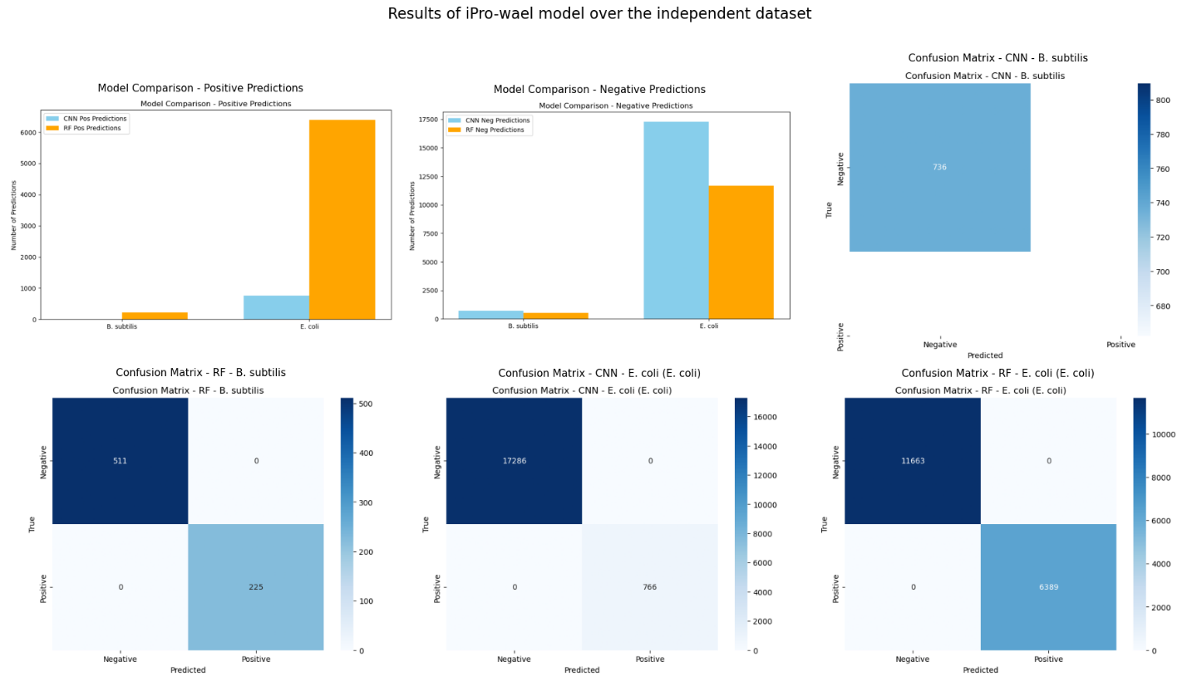
Figure.3: iPro-wael model

Performance Evaluation of Archaeal Promoter Prediction Models
In this study, we critically assessed existing archaeal promoter prediction models based on three research papers (65,66,67). Out of the three, only one paper made the model’s pre-trained weights available, while the others did not, which is a significant limitation for reproducibility and further improvement. Utilizing the pre-trained weights, we tested the models on an independent curated dataset. The results, as depicted in the attached figure, highlight a noticeable drop in performance when the model, trained on the iProm-Archaea dataset, was tested on our data. Specifically, the accuracy dropped from 88.95% on the training/validation dataset to just 43.64% on the independent test set, indicating a performance degradation of 45.31% as shown in figure. This decline suggests that while the model performs well on training data, its ability to generalize to new, independent data is limited, likely due to overfitting, limited data diversity in the training set, or a mismatch between the training and testing conditions. This limitation underscores the need for publicly available pre-trained weights and more robust models capable of generalizing to diverse datasets.
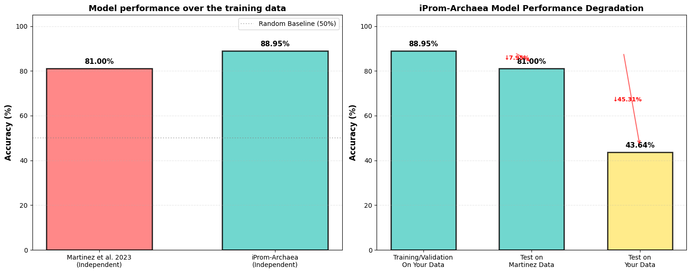
Figure.2: iPro-Archaea

Species-Specific Promoter Motif Signatures and Conservation Patterns
Motif discovery across multiple species revealed distinct and biologically meaningful nucleotide conservation patterns associated with promoter regions, as illustrated in the figure. In prokaryotic organisms such as E. coli, motifs exhibit strong conservation of G, C, and A nucleotides, with GC-rich and A/G-dominant segments indicating stable and well-defined promoter structures. These motifs often display clear position-specific conservation, suggesting functional binding sites that are critical for transcription initiation. In contrast, eukaryotic organisms including D. melanogaster, human, and mouse display more complex and variable motif architectures, characterized by mixed AT-rich and TG-dominant regions, reflecting higher regulatory complexity and diverse transcriptional control mechanisms. The variability in motif height and nucleotide distribution across positions indicates flexible binding preferences and combinatorial regulation. Plant promoters show prominent GC-rich conservation, suggesting stable regulatory elements, while archaeal promoters exhibit strong AT-rich patterns consistent with their distinct transcriptional machinery. Additionally, the sequence logos highlight conserved core regions surrounded by less constrained flanking positions, emphasizing both conserved functional elements and adaptable sequence contexts. Overall, these observations demonstrate that promoter sequences possess species-specific signatures, where nucleotide composition and conservation vary significantly across biological domains. This highlights the importance of incorporating domain-aware features in promoter prediction models and supports the need for generalized frameworks capable of capturing both conserved and species-specific regulatory patterns.
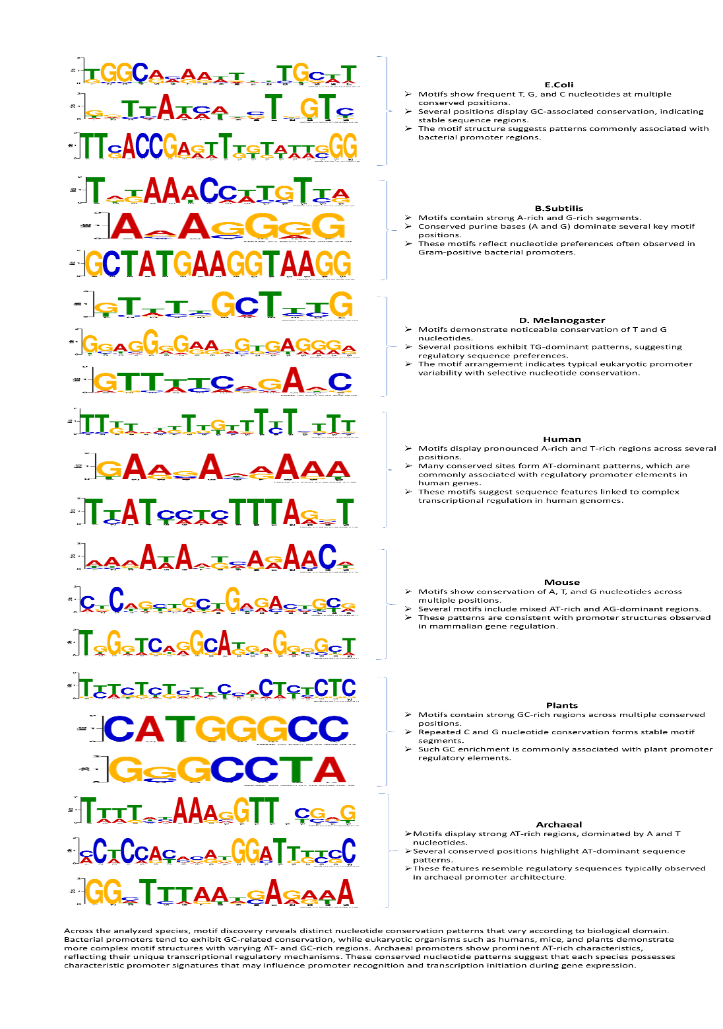
Figure.8: Motif Analysis Across Multiple Species

Conclusions

In this study, multiple state-of-the-art promoter prediction models were analyzed; however, only a limited number of them provided accessible pre-trained weights or executable frameworks that allowed evaluation on an independent dataset. Among all reviewed approaches, only a few models could be successfully executed and tested, while others were restricted due to reproducibility issues, lack of publicly available weights, incompatible dependencies, or incomplete feature extraction pipelines. The comparative analysis demonstrates a significant discrepancy between the performance reported in original papers and the results obtained on the independent dataset. While some models maintain high precision, they exhibit noticeable degradation in accuracy, recall, and F1-score, indicating limited generalization capability on unseen data. This highlights an important concern in promoter prediction research: many models are optimized for specific datasets and fail to generalize effectively in real-world scenarios. Therefore, the availability of reproducible implementations, transparent feature extraction methods, and robust evaluation on independent datasets is essential for ensuring the reliability and practical applicability of promoter prediction models.

References
- J. Lewis, Molecular Biology of the Cell, Garland Science, 2014.
- T. D. B. Michael T. Madigan, Brock Biology of Microorganisms, Pearson, 2021.
- H. Lodish, Molecular cell biology, W.H. Freeman/Macmillan Learning, 2016.
- M. Zhang, C. Jia, F. Li, C. Li, Y. Zhu, T. Akutsu, G. I. Webb, Q. Zou, L. J. M. Coin, and J. Song, "Critical assessment of computational tools for prokaryotic and eukaryotic promoter prediction," Briefings in Bioinformatics, vol. 23, no. 2, pp. 1–25, 2022
- S. de Avila e Silva, D. L. Notari, F. A. Neis, H. G. Ribeiro, and S. Echeverrigaray, "BacPP: A web-based tool for Gram-negative bacterial promoter prediction," Genet. Mol. Res., vol. 15, no. 2, Article gmr.15027973, Apr. 2016.
- H. Lin, Z.-Y. Liang, H. Tang, and W. Chen, "Identifying Sigma70 promoters with novel pseudo nucleotide composition," IEEE/ACM Trans. on Comput. Biol. and Bioinf., vol. 16, no. 4, pp. 1316-1321, Jul./Aug. 2019.
- I. A. Shahmuradov, R. M. Razali, S. Bougouffa, A. Radovanovic, and V. B. Bajic, "bTSSfinder: a novel tool for the prediction of promoters in cyanobacteria and Escherichia coli," Bioinformatics, vol. 33, no. 3, pp. 334-340, Mar. 2017.
- B. Liu, F. Yang, D.-S. Huang, and K.-C. Chou, "iPromoter-2L: a two-layer predictor for identifying promoters and their types by multi-window-based PseKNC," Bioinformatics, vol. 34, no. 1, pp. 33-40, Jan. 2018.
- S. Wang, X. Cheng, Y. Li, M. Wu, and Y. Zhao, "Image-based promoter prediction: a promoter prediction method based on evolutionarily generated patterns," Sci. Rep., vol. 8, no. 1, p. 17695, 2018.
- W. He, C. Jia, Y. Duan, and Q. Zou, "70ProPred: a predictor for discovering sigma70 promoters based on combining multiple features," BMC Syst. Biol., vol. 12, Suppl. 4, p. 44, 2018.
- M. S. Rahman, U. Aktar, M. R. Jani, and S. Shatabda, "iPro70-FMWin: Identifying Sigma70 promoters using multiple windowing and minimal features," Mol. Genet. Genomics, vol. 294, no. 3, pp. 693-706, Feb. 2019.
- X. Xiao, Z.-C. Xu, W.-R. Qiu, P. Wang, H.-T. Ge, and K.-C. Chou, "iPSW(2L)-PseKNC: A two-layer predictor for identifying promoters and their strength by hybrid features via pseudo K-tuple nucleotide composition," Genomics, vol. 111, no. 3, pp. 1785-1793, Mar. 2019.
- N. Q. K. Le, E. K. Y. Yapp, N. Nagasundaram, and H.-Y. Yeh, "Classifying promoters by interpreting the hidden information of DNA sequences via deep learning and combination of continuous FastText n-grams," Front. Bioeng. Biotechnol., vol. 7, Article 305, Nov. 2019.
- M. Zhang, F. Li, T. T. Marquez-Lago, A. Leier, C. Fan, C. Kwoh, K.-C. Chou, J. Song, and C. Jia, "MULTiPly: a novel multi-layer predictor for discovering general and specific types of promoters," Bioinformatics, vol. 35, no. 17, pp. 2957–2965, 2019.
- B. Liu and K. Li, "iPromoter-2L2.0: Identifying promoters and their types by combining smoothing cutting window algorithm and sequence-based features," Mol. Ther. Nucleic Acids, vol. 18, pp. 80-87, Dec. 2019.
- B. Liu, L. Han, X. Liu, J. Wu, and Q. Ma, "Computational prediction of sigma-54 promoters in bacterial genomes by integrating motif finding and machine learning strategies," IEEE/ACM Trans. Comput. Biol. Bioinform., vol. 16, no. 4, pp. 1211-1218, Jul./Aug. 2019.
- M. S. Rahman, U. Aktar, M. R. Jani, and S. Shatabda, "iPromoter-FSEn: Identification of bacterial σ70 promoter sequences using feature subspace-based ensemble classifier," Genomics, vol. 111, no. 7, pp. 1160-1166, 2019.
- M. Sampaio, M. Rocha, H. Oliveira, and O. Dias, "Predicting promoters in phage genomes using machine learning models," Proc. PACBB 2019, vol. 1005, pp. 105–112, 2019.
- R. A. Amin, C. R. Rahman, S. Ahmed, M. H. Rahman Sifat, M. N. K. Liton, M. M. Rahman, M. Z. Hossain Khan, and S. Shatabda, "iPromoter-BnCNN: a novel branched CNN-based predictor for identifying and classifying sigma promoters," Bioinformatics, vol. 36, no. 19, pp. 4869-4875, 2020.
- H. Tayara, M. Tahir, and K. T. Chong, "Identification of prokaryotic promoters and their strength by integrating heterogeneous features," Genomics, vol. 112, no. 8, pp. 1396–1403, 2020.
- A. Mishra, S. Dhanda, P. Siwach, S. Aggarwal, and B. Jayaram, "A novel method SEProm for prokaryotic promoter prediction based on DNA structure and energetics," Bioinformatics, vol. 36, no. 8, pp. 2375–2384, 2020.
- M. Shujaat, A. Wahab, H. Tayara, and K. T. Chong, "pcPromoter-CNN: A CNN-based prediction and classification of promoters," Genes, vol. 11, no. 12, p. 1529, Dec. 2020.
- R. Chevez-Guardado and L. Peña-Castillo, "Promotech: A general tool for bacterial promoter recognition," Genome Biology, vol. 22, p. 318, 2021.
- Y. Lyu, W. He, S. Li, Q. Zou, and F. Guo, "iPro2L-PSTKNC: A two-layer predictor for discovering various types of promoters by position specific of nucleotide composition," IEEE J. Biomed. Health Informat., vol. 25, no. 6, pp. 2329–2337, June 2021.
- Y. Liang, S. Zhang, H. Qiao, and Y. Yao, "iPromoter-ET: Identifying promoters and their strength by extremely randomized trees-based feature selection," Analytical Biochemistry, vol. 630, p. 114335, Aug. 2021.
- R. Bhukya, A. Kumari, S. Amilpur, and C. M. Dasari, "PPred-PCKSM: A multi-layer predictor for identifying promoters and their variants using position-based features," Comput. Biol. Chem., vol. 97, p. 107623, Jan. 2022.
- M. Wang, F. Li, H. Wu, Q. Liu, and S. Li, "PredPromoter-MF(2L): A novel approach of promoter prediction based on multi-source feature fusion and deep forest," Interdisciplinary Sciences: Computational Life Sciences, vol. 14, no. 5, pp. 697–711, 2022.
- M. Bernardino and R. Beiko, "Genome-scale prediction of bacterial promoters using a neural-network-based method," BioSystems, vol. 221, p. 104771, Sep. 2022.
- H. Li, L. Shi, W. Gao, Z. Zhang, L. Zhang, Y. Zhao, and G. Wang, "dPromoter-XGBoost: Detecting promoters and strength by combining multiple descriptors and feature selection using XGBoost," Methods, vol. 204, pp. 215–222, Jan. 2022.
- N. Q. K. Le, Q.-T. Ho, V.-N. Nguyen, and J.-S. Chang, "BERT-Promoter: An improved sequence-based predictor of DNA promoter using BERT pre-trained model and SHAP feature selection," Computational Biology and Chemistry, vol. 99, p. 107732, 2022.
- M. Shujaat, J. S. Jin, H. Tayara, and K. T. Chong, "iProm-phage: A two-layer model to identify phage promoters and their types using a convolutional neural network," Front. Microbiol., vol. 13, Article 1061122, Nov. 2022.
- D. Hernández, N. Jara, M. Araya, R. E. Durán, and C. Buil-Aranda, "PromoterLCNN: A light CNN-based promoter prediction and classification model," Genes, vol. 13, no. 7, p. 1126, Jun. 2022.
- M. Shujaat, H. Kim, H. Tayara, and K. T. Chong, "iProm-Sigma54: A CNN-based prediction tool for σ54 promoters," Cells, vol. 12, no. 6, p. 829, Mar. 2023.
- A. Raza, W. Alam, S. Khan, M. Tahir, and K. T. Chong, "iPro-TCN: Prediction of DNA promoters recognition and their strength using temporal convolutional network," IEEE Access, vol. 11, pp. 66113–66121, 2023.
- B. Peng, G. Sun, and Y. Fan, "iProL: Identifying DNA promoters from sequence information based on Longformer pre-trained model," BMC Bioinformatics, vol. 25, no. 224, 2024.
- Y. Li, X. Wei, Q. Yang, A. Xiong, X. Li, Q. Zou, F. Cui, and Z. Zhang, "msBERT-Promoter: A multi-scale ensemble predictor based on BERT pre-trained model for the two-stage prediction of DNA promoters and their strengths," BMC Biology, vol. 22, no. 126, 2024.
- X. Xiao, Z. Hu, Z. Luo, and Z. Xu, "iPSI(2L)-EDL: A two-layer predictor for identifying promoters and their types based on ensemble deep learning," Current Bioinformatics, vol. 19, no. 4, pp. 327–340, 2024.
- G. Sganzerla Martinez, E. Perez-Rueda, A. Kumar, M. Dutt, C. Rodríguez Maya, L. Ledesma-Dominguez, P. Lenz Casa, A. Kumar, S. de Avila e Silva, and D. J. Kelvin, "CDBProm: The comprehensive directory of bacterial promoters," NAR Genomics and Bioinformatics, vol. 6, no. 1, p. lqae018, Feb. 2024.
- R. Lei, J. Jia, L. Qin, and X. Wei, "iPro2L-DG: Hybrid network based on improved DenseNet and global attention mechanism for identifying promoter sequences," Heliyon, vol. 10, e27364, Mar. 2024.
- T. Achterberg and A. de Jong, "ProPr54 web server: predicting σ54 promoters and regulon with a hybrid convolutional and recurrent deep neural network," NAR Genomics and Bioinformatics, vol. 7, no. 1, lqae188, Jan. 2025.
- L. Coppens and R. Ledesma-Amaro, "PromoterAtlas: Decoding regulatory sequences across Gammaproteobacteria using a transformer model," bioRxiv, 2025.
- G. M. Şilbir, "pPromoter-FCGR: Deep Learning on Frequency Chaos Game Representation for Prediction of DNA Promoters," Academic Platform Journal of Engineering and Smart Systems (APJESS), vol. 13, no. 2, pp. 61–70, 2025.
- W. Xu, L. Zhang, and Y. Lu, "SD-MSAEs: Promoter recognition in human genome based on deep feature extraction," Journal of Biomedical Informatics, vol. 61, pp. 55–62, Mar. 2016.
- I. A. Shahmuradov, R. Kh. Umarov, and V. V. Solovyev, "TSSPlant: a new tool for prediction of plant Pol II promoters," Nucleic Acids Research, vol. 45, no. 8, e65, 2017.
- M. Triska, V. Solovyev, A. Baranova, A. Kel, T. V. Tatarinova, "Nucleotide patterns aiding in prediction of eukaryotic promoters," PLoS ONE, vol. 12, no. 11, p. e0187243, Nov. 2017.
- V. R. Yella, A. Kumar, and M. Bansal, "Identification of putative promoters in 48 eukaryotic genomes on the basis of DNA free energy," Scientific Reports, vol. 8, no. 4520, pp. 1–14, 2018.
- Z. Zhuang, X. Shen, and W. Pan, "A simple convolutional neural network for prediction of enhancer–promoter interactions with DNA sequence data," Bioinformatics, vol. 35, no. 17, pp. 2899–2906, 2019.
- M. A. Korotkova, A. M. Kamionskya, and E. V. Korotkov, "A mathematical method for the classification of promoter sequences from the A. thaliana genome," Journal of Physics: Conference Series, vol. 1686, no. 1, p. 012031, 2020.
- A. N. Bubnova, I. V. Yakovleva, E. V. Korotkov, and A. M. Kamionskaya, "In silico verification of predicted potential promoter sequences in the rice (Oryza sativa) genome," Plants, vol. 12, no. 12, p. 3573, Dec. 2023.
- M. Shujaat, S. B. Lee, H. Tayara, and K. T. Chong, "Cr-Prom: A convolutional neural network-based model for the prediction of rice promoters," IEEE Access, vol. 9, pp. 81484–81492, 2021.
- A. Sun, X. Xiao, and Z. Xu, "iPTT(2L)-CNN: A two-layer predictor for identifying promoters and their types in plant genomes by convolutional neural network," Computational and Mathematical Methods in Medicine, vol. 2021, Article ID 6636350, 9 pages, 2021.
- J. Kim, M. Shujaat, H. Tayara, "iProm-Zea: A two-layer model to identify Zea mays promoters and classify their types (TATA or TATA-less promoters)," Genomics, vol. 114, p. 110384, May 2022.
- Z.-W. Ma, Z. Chen, J.-P. Zhao, and C.-H. Zheng, "DeeProPre: A deep learning model for promoter prediction based on convolutional neural network and bidirectional long short-term memory with attention mechanism," Computational Biology and Chemistry, vol. 101, p. 107770, 2022.
- T.-H. Nguyen-Vo, Q. H. Trinh, L. Nguyen, P.-U. Nguyen-Hoang, S. Rahardja, and B. P. Nguyen, "iPromoter-Seqvec: Identifying TATA and non-TATA promoters in human and mouse genomes using bidirectional long short-term memory and sequence-embedded features," BMC Genomics, vol. 23, p. 681, Dec. 2022.
- Y. Wang, S. Tai, S. Zhang, N. Sheng, and X. Xie, "PromGER: Promoter prediction based on graph embedding and ensemble learning for eukaryotic sequences," Genes, vol. 14, p. 1441, Jul. 2023.
- A. Mengen and E. Delibaş, "Promoter Classification in Human Genome via DNA2Vec and UNK-Aware Deep Neural Networks," Journal of Engineering Faculty, vol. 3, no. 1, pp. 92-99, 2025.
- Y. Li, M. Gao, J. Bian, K. Zhao, D. Li, and G. Wang, "OntoGene: Knowledge-enhanced BERT for promoter identification," Sci China Inf Sci, vol. 68, no. 7, pp. 170106:1–170106:13, Jul. 2025.
- R. K. Umarov and V. V. Solovyev, "Recognition of prokaryotic and eukaryotic promoters using convolutional deep learning neural networks," PLoS ONE, vol. 12, no. 2, p. e0171410, Feb. 2017.
- H.-Y. Lai, Z.-Y. Zhang, Z.-D. Su, W. Su, H. Ding, W. Chen, and H. Lin, "iProEP: A computational predictor for predicting promoters," Molecular Therapy: Nucleic Acids, vol. 17, pp. 337–346, 2019.
- S. Menon, S. Piramanayakam, and G. Agarwal, "Computational identification of promoter regions in prokaryotes and eukaryotes," EPRA International Journal of Agriculture and Rural Economic Research, vol. 9, no. 7, pp. 1-12, July 2021.
- L. Moraes, P. Silva, E. Luz, and G. Moreira, "CapsProm: A capsule network for promoter prediction," Computers in Biology and Medicine, vol. 147, p. 105627, 2022.
- P. Zhang, H. Zhang, and H. Wu, "iPro-WAEL: A comprehensive and robust framework for identifying promoters in multiple species," Nucleic Acids Research, vol. 50, no. 18, pp. 10278–10289, Sep. 2022.
- R. Luo, J. Liu, L. Guan, and M. Li, "HybProm: An attention-assisted hybrid CNN-BiLSTM model for the interpretable prediction of DNA promoters," Methods, vol. 235, pp. 71–80, 2025.
- Q. Zhou, J. Meng, and H. Luo, "iPro-CSAF: Identification of promoters based on convolutional spiking neural networks and spiking attention mechanism," PeerJ Computer Science, vol. 11, Article e2761, Mar. 2025.
- G. Sganzerla Martinez, E. Perez-Rueda, A. Kumar, S. Sarkar, and S. deAvila e Silva, "Explainable artificial intelligence as a reliable annotator of archaeal promoter regions," Scientific Reports, vol. 13, p. 1763, Mar. 2023.
- S. Ithurbide, N. Buan, and S. Schulze, "Advancing archaeal research through FAIR resource and data sharing, and inclusive community building," Communications Biology, vol. 8, p. 519, 2025.
- M. Shujaat and S.-Q. Mao, "iProm-Archaea: An AI-based tool for archaeal promoter recognition and annotation," BMC Genomics, vol. 26, no. 936, 2025.

